## Flatfile

## Implementation POC: Royce *(IM to fill)* CX POC: *[IMP to Add]*

### 

### 

| Notes Sections   *(AE to fill if they have, Implementation to be completion DRI on handoff)*   * Info on how merchant bills   Typically bill with a one time upfront commitment that is drawn against as usage is used. Just implemented Sequence but really like our platform. As of now they are going to bill out of sequence and we are going to create invoices but not send them and then do cash app and rev rec  1) What is the merchant temperament?  Josh Baker (dir. of accounting, reports to COO) is great, will definitely help us against sequence, very kind  Victoria is an accountant and is very quiet, was a little timid about the idea of AI  3) What are the Tabs features that the key POC cares about?  Cash app and rev rec |
| --- |

### Billing model *(Entire Section: Implementation to fill section)*

* Are there unique things about the customer creation process for this merchant?
* Information on how merchant bills
* How contract is broken up
* One off things to know about the merchant

### Customer Creation

* Create customer if it doesn’t already exist (should exist)

### Contract Processing Steps *(Entire Section: Implementation/Success to fill Post-Go Live)*

* BTs are typically found in Cloud Service Fees table
* Do not create separate BTs for discounts. Use in-line discounting (+ Add discount button).
* Ignore $0 "included" billing terms
* **Billing Start Date:** will be in “Subscription Start Date” section
* **Service Start Date:** same as billing start date
* **Months of Service:** will be in “Subscription Period” or “Initial Service Term” section (if none, default to 12 months)
* **Frequency:** check “invoice period” or “billing terms” section or similar to see if fees are billed annually or monthly or otherwise (if none, default to annually upfront)
  + Ignore the subtotal column header and follow the invoice period section on the first page. If subtotal column says “Monthly amounts” but the invoices are sent annually, these amounts will need to be multiplied by 12
  + If the fine print below the table conflicts with the Billing Terms section, ignore
    - For example, Billing Terms section says fees are invoiced monthly but fine print says “All custom contracts are invoiced annually with the exception of services” - ignore the fine print here
* **Net Terms:** check “payment period” or “billing terms” section (if none, default to 30 days)
* **Total Price:** 
  + Unless the subtotal header specifies that it is a “monthly” subtotal, we can assume that the prices listed are annual
    - Will need to divide prices by whatever the appropriate frequency is.
      * For example, quarterly invoicing will be divided by 4.
      * Usage BTs will by default be monthly.
        + For Annual Seats - do not divide the price even if subtotal column implies that you should
* 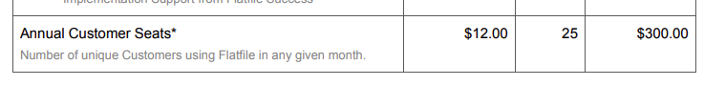
  + - * + This should be a monthly BT in arrears for $12 no matter what the Billing Terms section says
    - ional Data Importer Pro - this SKU will be a FLAT BT but NOT a Usage BT. It can follow the frequency from the Billing Terms section
* 
* **Quantity:** 
  + use listed amount in table
  + Note that usage BTs with 0 quantity will just need to be usage BTs - no need to create an additional flat BT
  + For usage BTs with quantities greater than 0, process first as a flat BT with the list amount and quantity and then also create a usage BT for the overage (this should be monthly in arrears)
    - Check the item description to see how it should be billed. For example: “Additional files imported beyond precontracted amount will be billed at $0.25 per file”
* **Item Names:** listed in table
* **Revenue Category:** Select either "service" or "subscription" based on line item language for all flat BTs. All usage BTs must be mapped to the "usage" revenue category.
* **Usage BTs:**
  + Events should already be created - if not, please flag
  + Most usage is pre-paid upfront for an initial volume. This is reflected when there is a quantity greater than 1 in the usage BT (screenshot below).

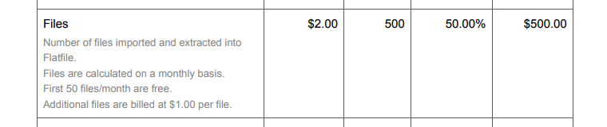

* + - First - create a flat billing term to represent this prepayment (e.g., $500 for files, billed once upfront, frequency can match the service period)
      * Need to check the subtotal column header to see what the amount should be
        + If header says “Monthly subtotal” but the invoice period says “Provider will send invoices annually” - you will need to multiply the flat BT by 12 to charge the full annual amount upfront
        + You will need to also multiply the amount by 12 for the usage AI piece.
        + The usage AI threshold amount should match the upfront BT. See instructions below for usage AI.
        + Never divide the files or PDV prices.
    - **Will need to turn on Usage AI when you see BTs with large quantities like Files and PDV in the screenshot.** Instructions (+ screenshot below):
      * Examples
        + [NEXL](https://garage.tabsplatform.com/prod/contracts/70784e77-26a0-4c71-a18d-402e88da9326/usage)
        + [Deputy](https://garage.tabsplatform.com/prod/contracts/e978baa6-d48e-409e-bf7b-ece1da7795fd/usage)
        + [Assignar](https://garage.tabsplatform.com/prod/contracts/8f15b2a0-05c1-452e-858d-0d5ef0e69d7d/terms/revenue) (example of prepaid quarterly invoicing)
      * Select “Has Threshold”
      * Threshold period = should be full service term
      * Select the individual products (usage BT)
      * Name of event + “Prepaid”
      * Threshold amount = subtotal amount
        + If it’s a monthly amount, you will need to multiply by 12 (or whatever the total months of service is)
      * Turn on “charges overages”

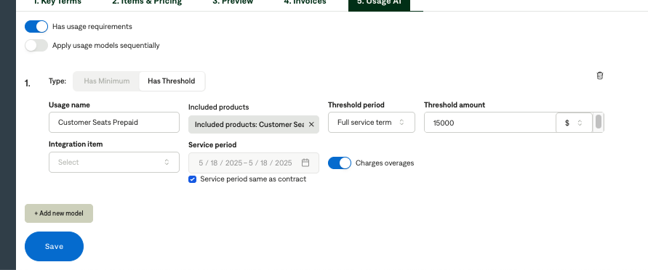

* + - If there are multiple BTs with a prepayment, you must follow these usage AI steps for each one. Do NOT select apply usage models sequentially
      * Example
    - If you haven’t already, create an additional usage BT - this is the usage BT you should select for **Included products** in usage AI
      * For the usage BT part, pay attention to the rules in the descriptions.
        + Example:

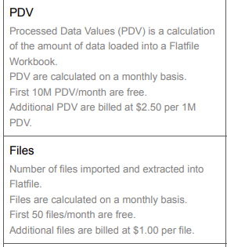

* + - * + For PDV, the usage BT should be a regular unit BT titled “PDV (1M Bundles)”

This is because it’s per 1M - ignore the 10M free part

* + - * + For Files, this should be a a tier unit BT

First tier is up to 50 free

Second tier is 51+ for 1.00 per file

* + - * + ***Revenue category: Usage events must be mapped to the "usage" revenue category.
* **Retainers / Credit - Usage AI Enablement**
  + If a contract includes a retainer line item (e.g., "Retainer: Draw-down account for usage fees"), treat as a prepaid credit to be applied toward usage.
  + Create a one-time flat billing term for the full amount of the retainer
  + Enable usage AI for these agreements to track credit usage against future usage events
  + Select Has Threshold
  + Call it Retainer
  + Only select the products the retainer covers in “Included Products”
    - This will likely only be the usage products

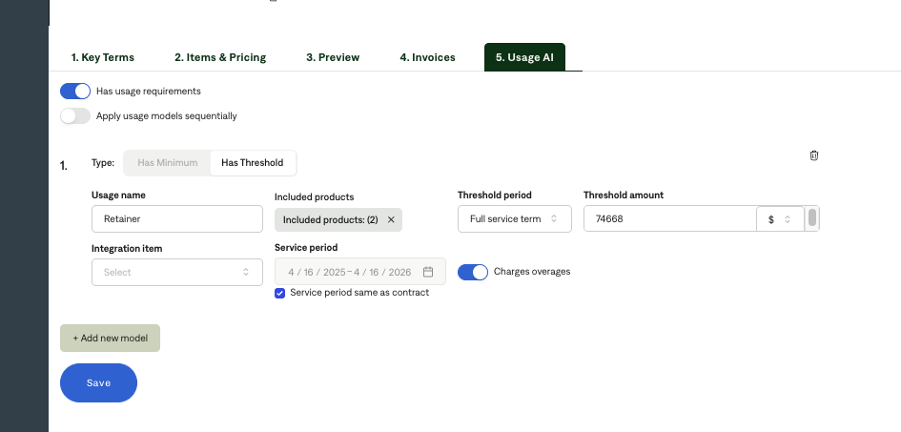

* + Select full service term
  + Make sure “Charges overages is turned on”
  + Examples to reference:
    - 0b34ca19-80a6-4fb4-b2c3-e98174163950implementat
    - 1b49eaf0-234d-484f-9710-e74b64b852d8
* Can Ignore
  + Optional Add-On Services

1. Specifics processing things the merchant has requested that may differ by contract (e.g. always back-date invoice date to final day of the month)
2. Default Service Term
   1. If None Listed, Ops Default is 1 Year
3. Default Net Payment Terms
   1. If None, Ops Default is 0
4. Default Billing Frequency
   1. If None Listed, Ops Default is Monthly
5. How do we handle taxes as a line item?
   1. If None Listed, Ops Default is every tax line item becomes a BT

### Events Processing (if necessary) *(Entire Section: Implementation/Success to fill Post-Go Live)*

* Any important information on events billing

Integration Items Processing (if necessary)  
*(Entire Section: Implementation/Success to fill Post-Go Live)*

* What are the instructions for assigning integration items?
* Example: All Statsig integrations items should be labeled as “Sales”
* Example: All “Pinata” integration items should be labeled as “Software Subscription Bundle” unless otherwise noted by Merchant

Post Processing Communications (if necessary)  
*(Entire Section: Implementation/Success to fill Post-Go Live)*

* Does the Ops Team need to notify anyone on the team re: completion of processing batches in Implementation or Active phase?
* Who needs to be notified and when?
  + Example:
    - Who: Customer Success [Azmat Aziz] needs to be notified
    - Where: Messari internal merchant channel
    - When: contracts are processed [Merchant Phase: Active]

### Customer Information *(Entire Section: Implementation/Success to fill Post-Go Live)*

* Any important information on specifics customers of this merchant
  + Special memo’s certain invoices require
  + Invoice changes due to merchant/customer relationship

### Feature Requests *(AE to fill for all requests prior to Imp handoff, Imp to fill prior to go-live/Success to fill to fill Post-Go Live)*

* FR 1
  + What is it
  + Why it's important
  + Urgency

### Merchant Calls *(AE to fill for all videos prior to Imp involvement, Imp to fill prior to go-live/Success to fill to fill Post-Go Live)*

* Loom recording links by dates

They are in the slack channel